DAVID ARNOLD

daverno@au1.ibm.com

Abstract

Instructions to show how to build and optionally run and test custom images/containers for IBM Cloud Pak for Integration components using RHOS core services  
and Tekton pipelines and testing with Rational tools

IBM Middleware Testing with RIT

Testing ICP4i custom images on RHOS 4.2 with Rational Integration Tester

Contents

Testing and Stubbing ACE and MQ custom image on RHOS instance with RIT 2

Overview 2

Importing RIT test project 3

Navigation 3

STUB 9

Configuring MQ 14

Configuring HTTP 15

Using RIT to test ACE Micro Service 1 on RHOS 15

Running ACE Micro Service 2 Stub on RIT 15

Testing ACE Micro Service 2 Stub on RIT 15

Secure gateway 16

Calling ACE MS2 stub 16

IBM MQ Queue Manager 20

Channel creation for Linux based queue manager 20

Channel creation for windows based queue manager 20

IBM Secure Gateway Service – IBM Cloud 21

IBM Secure Gateway Service – Client (Laptop end) 22

Windows firewall 23

Testing MQ via IBM Public IP – using RFHUTILC 23

Testing ACE Microservice 3 to Put to MQ via IBM Public IP 25

Route for ACE MS3 25

URL for ACE MS3 service 25

Data to test ACE MS3 service 25

Test with REST Client 26

Test Results 27

MQ Stub on RIT 27

RIT Test Stub receives message from ACE MS3 29

# Testing and Stubbing ACE and MQ custom image on RHOS instance with RIT

## Overview

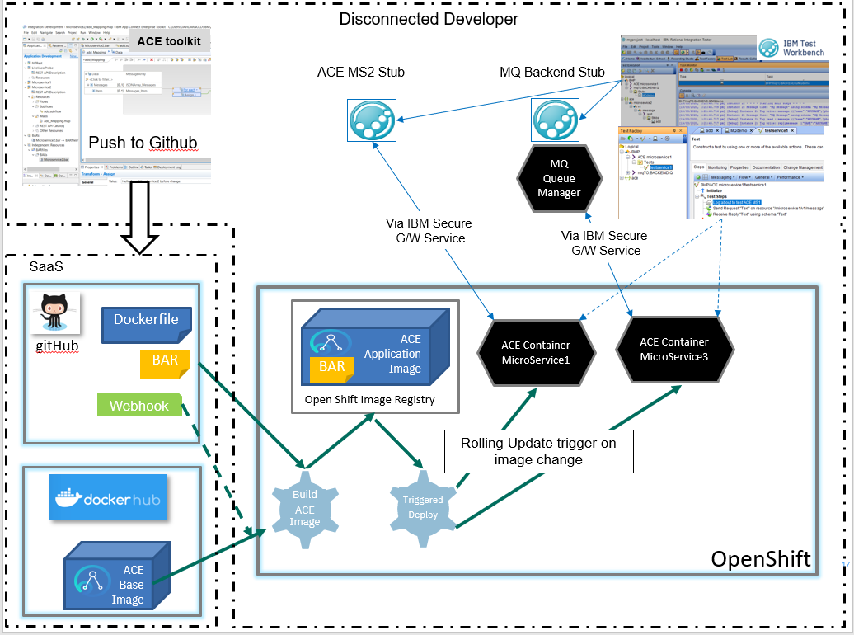

## Importing RIT test project

## Navigation

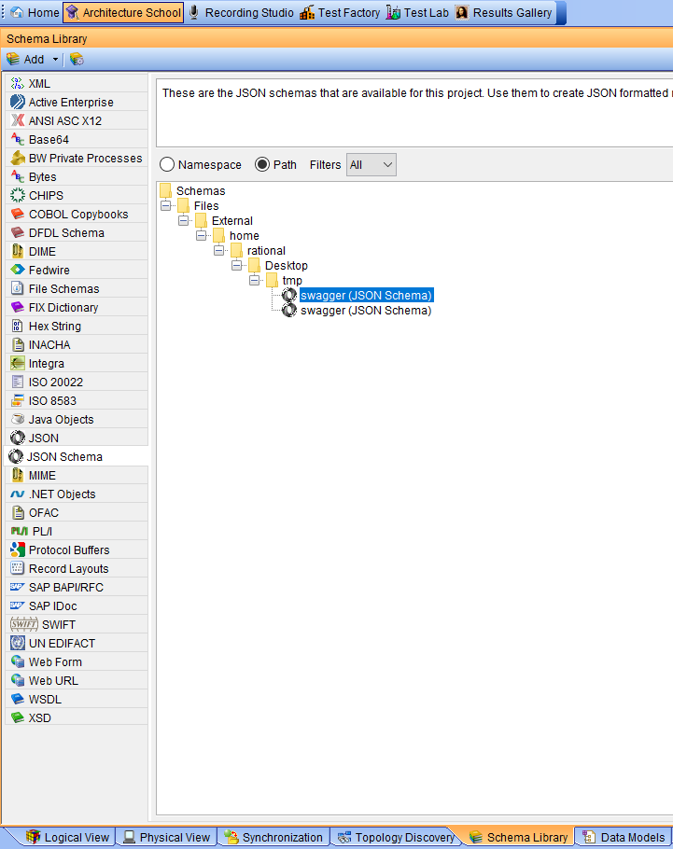

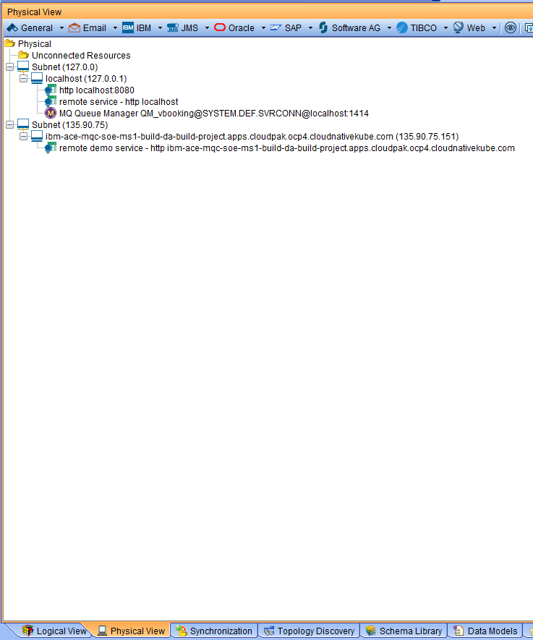

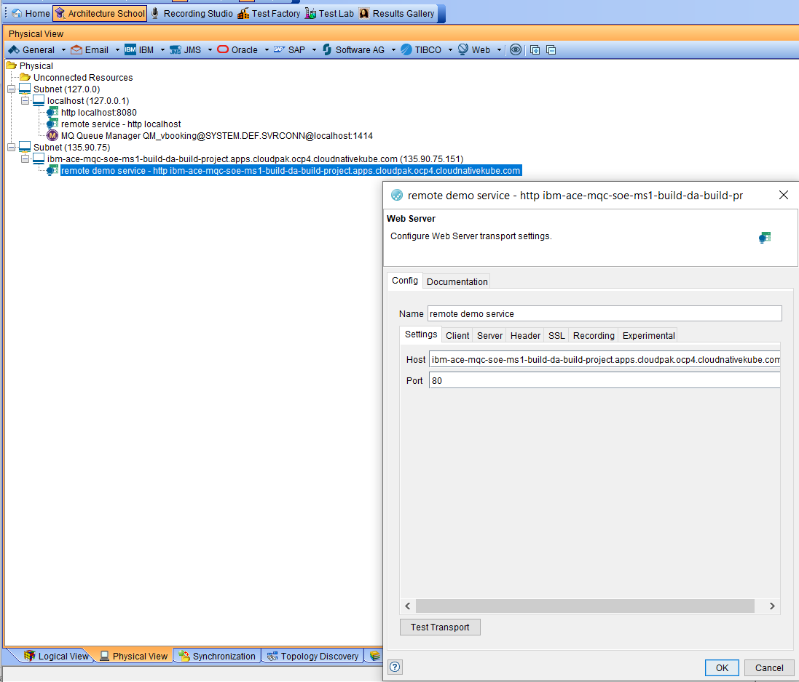

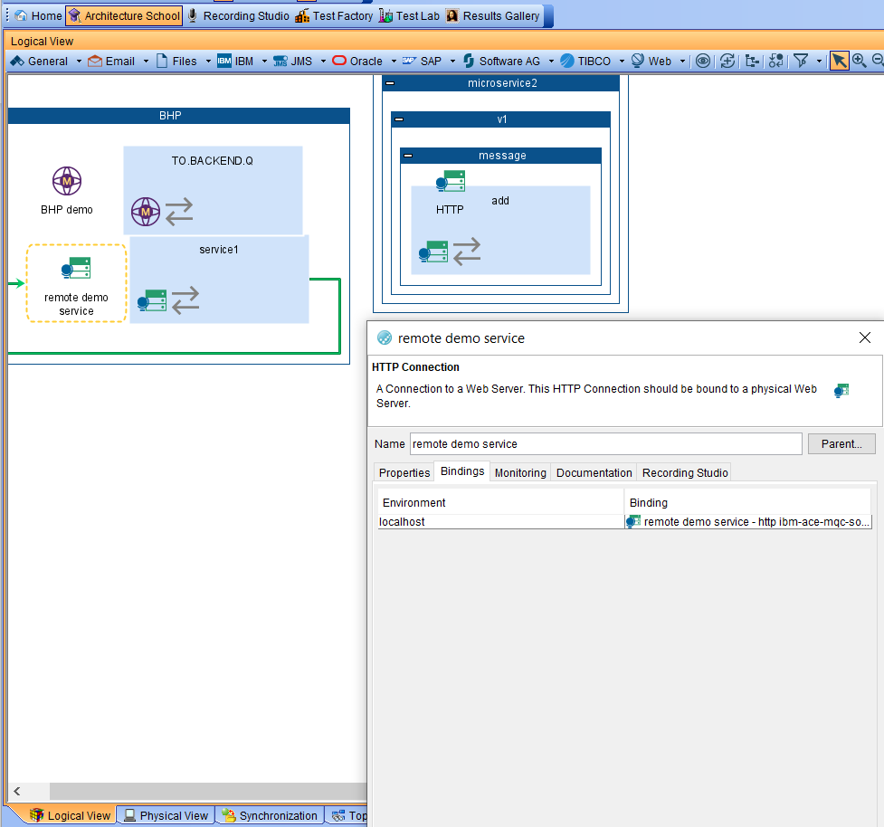

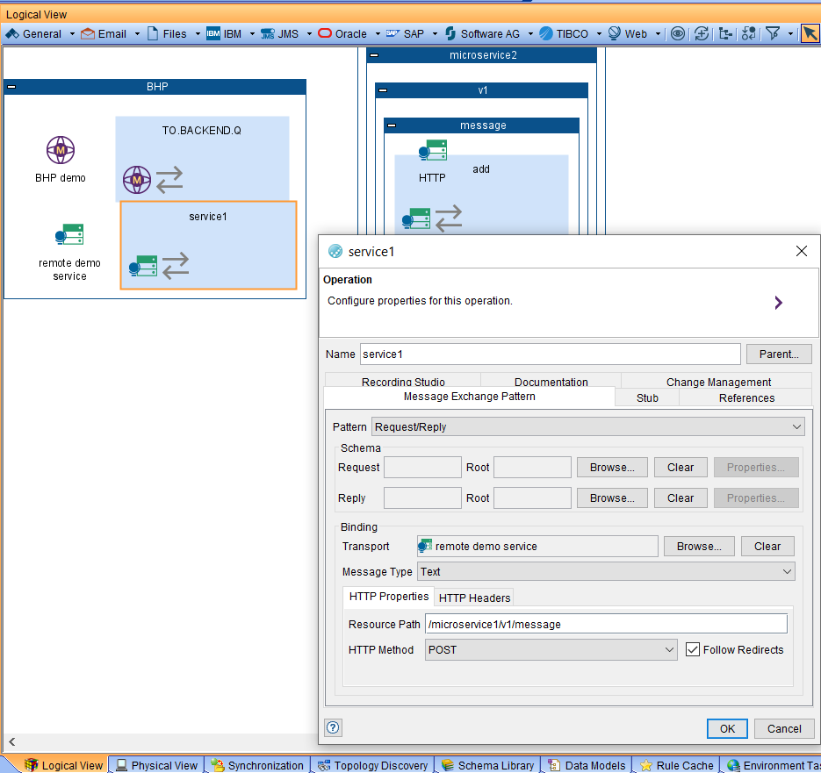

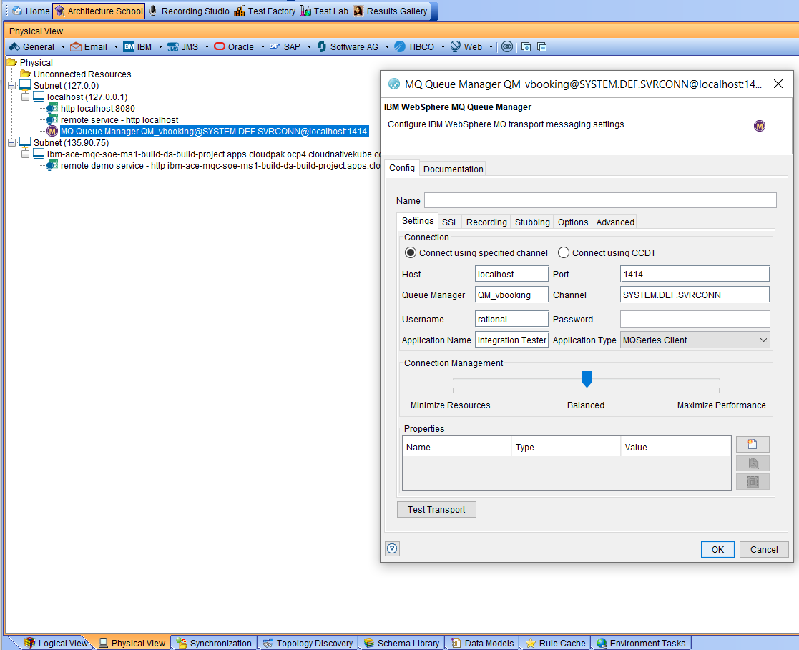

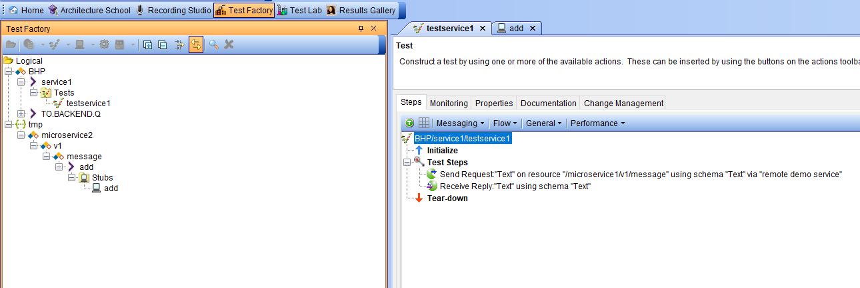

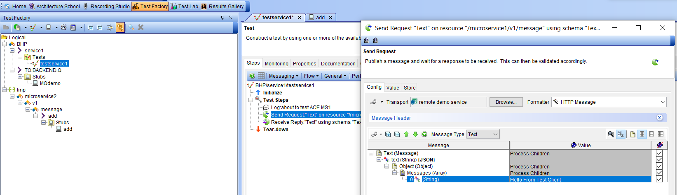

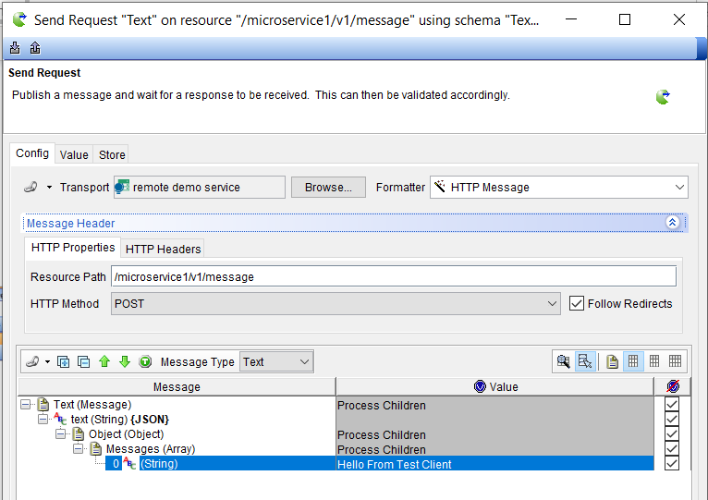

Defines the expected result – for comparison purposes

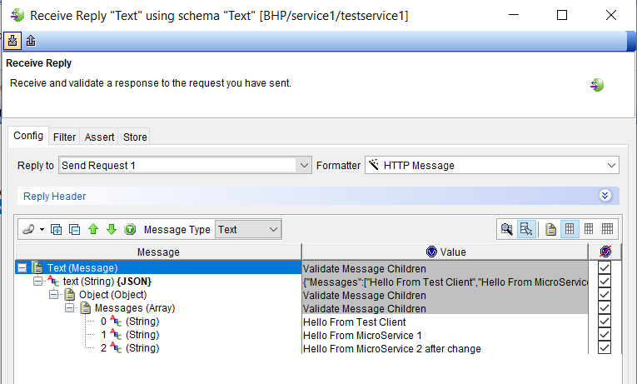

## STUB

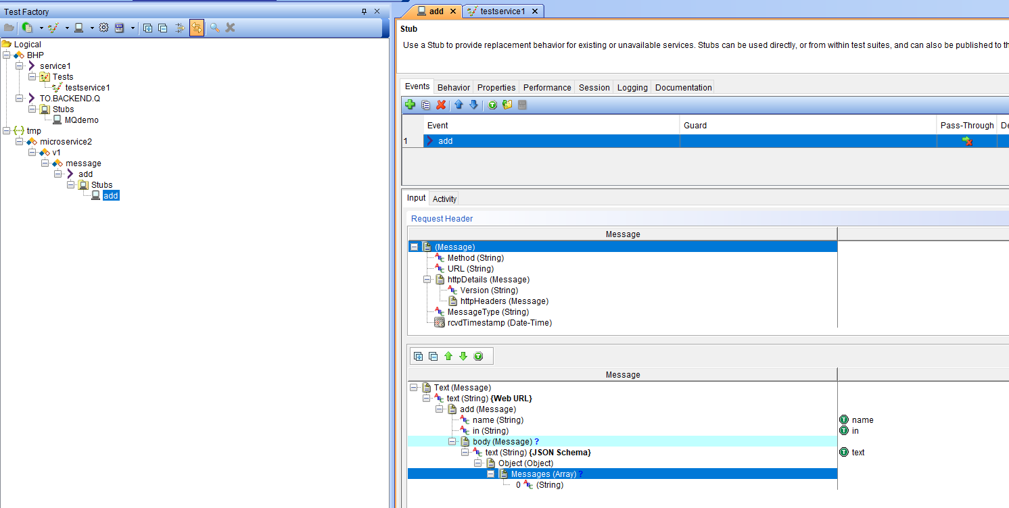

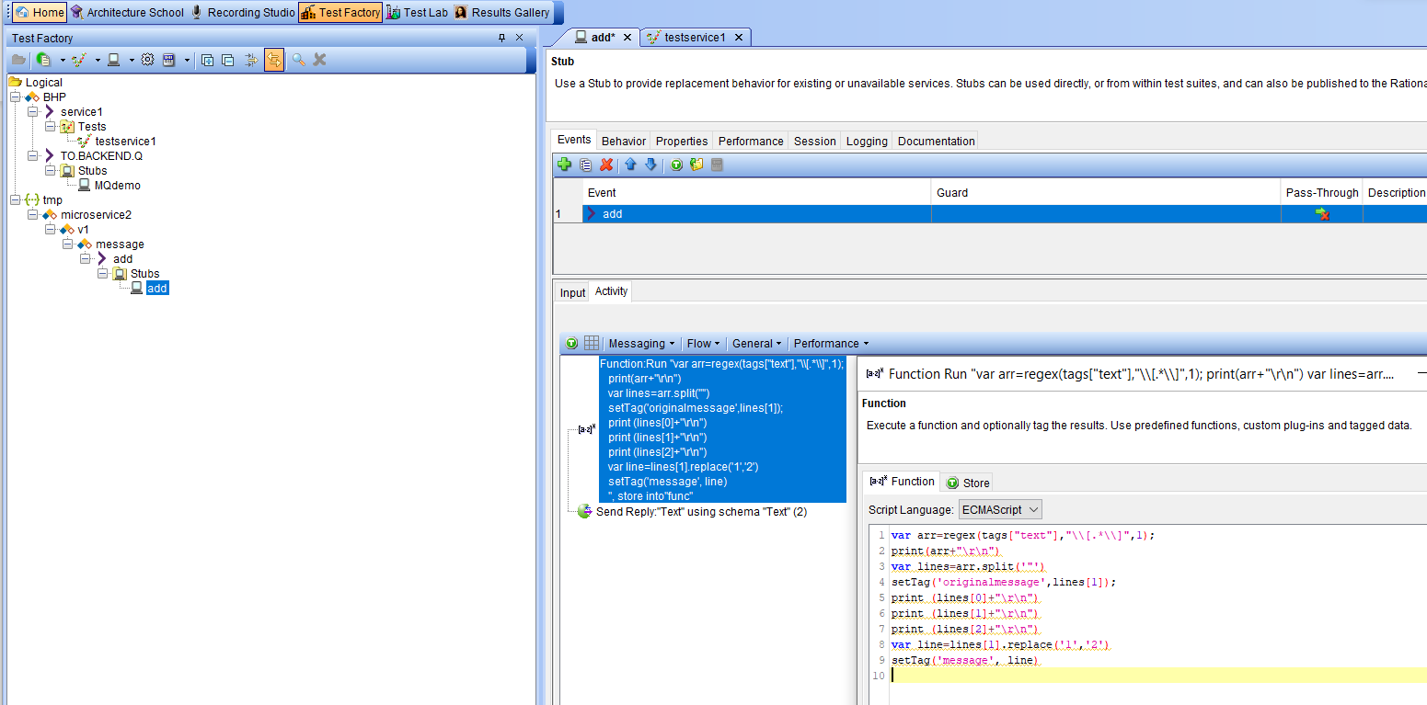

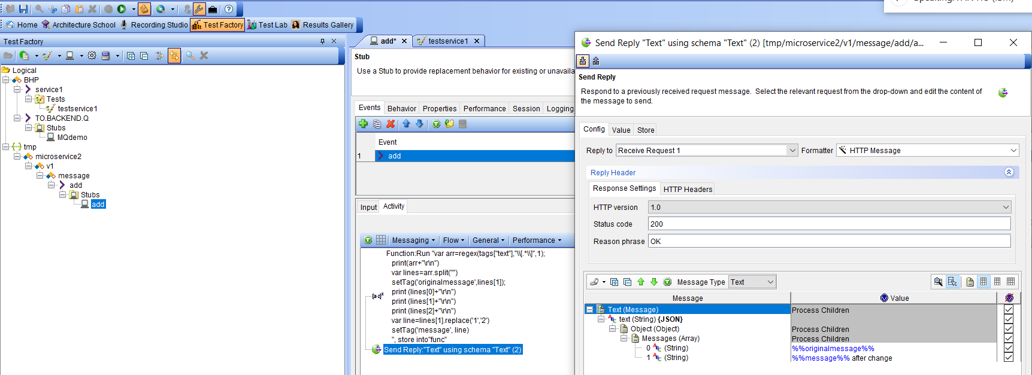

Run the stub

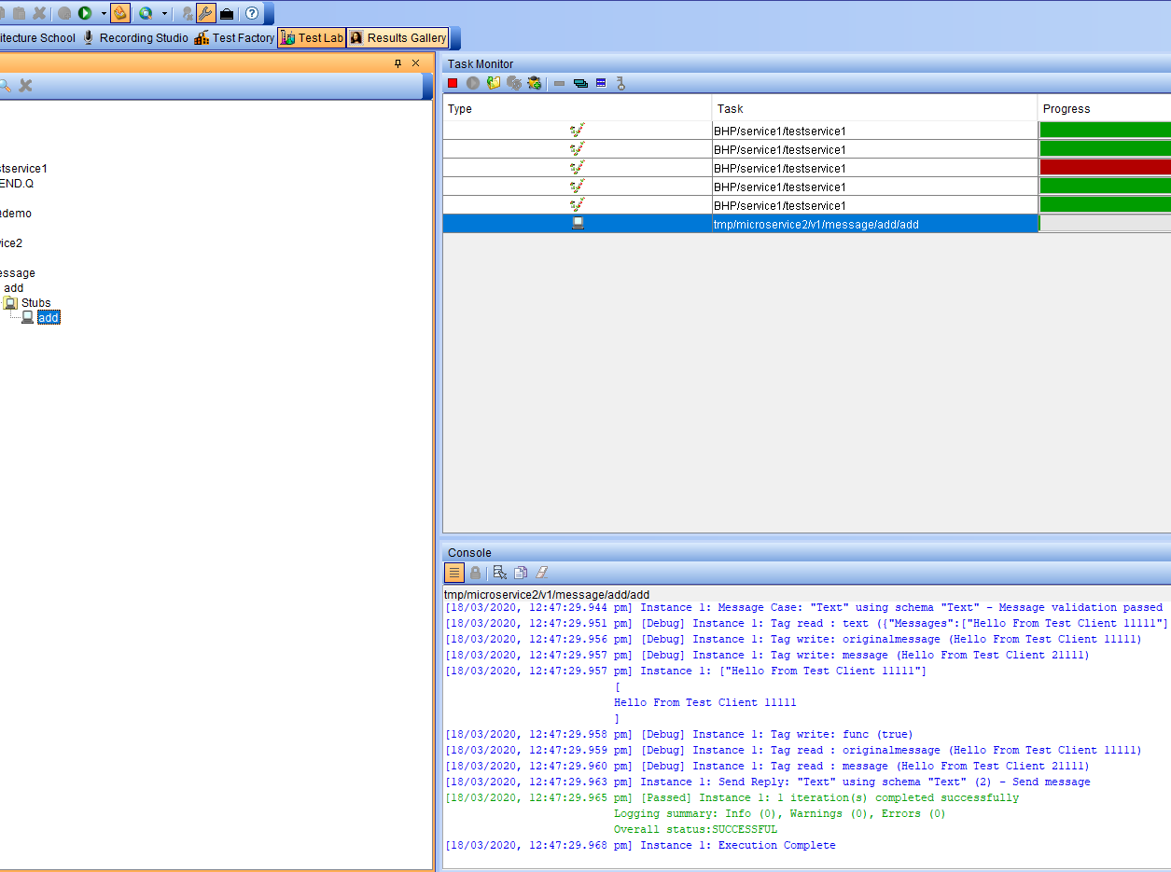

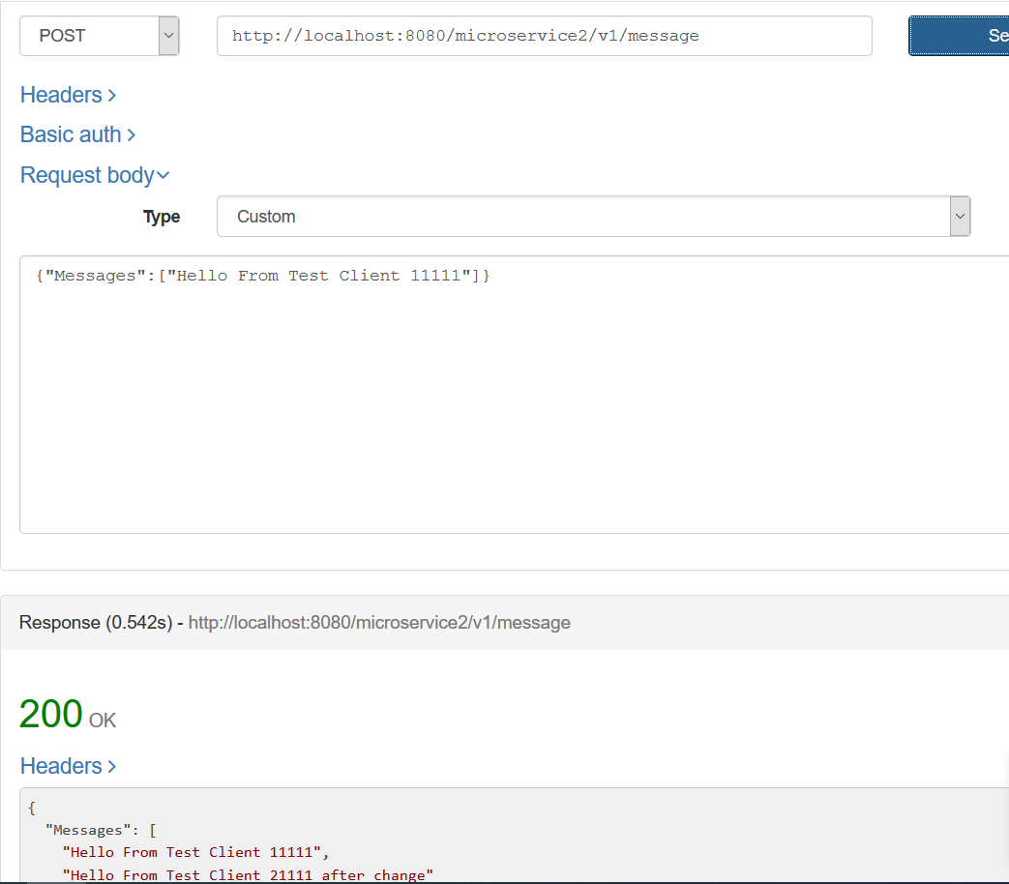

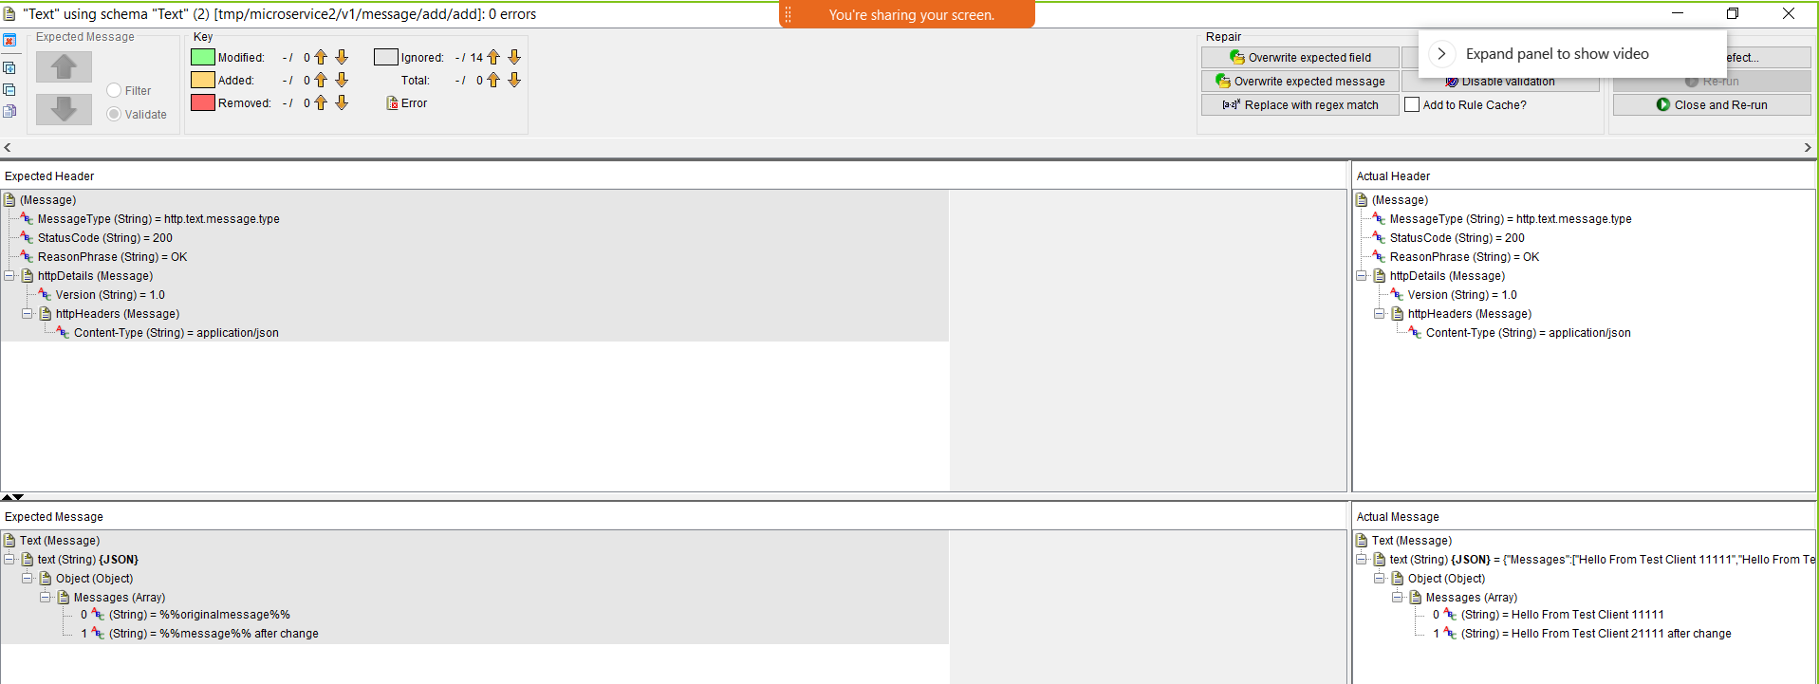

MQ Stub

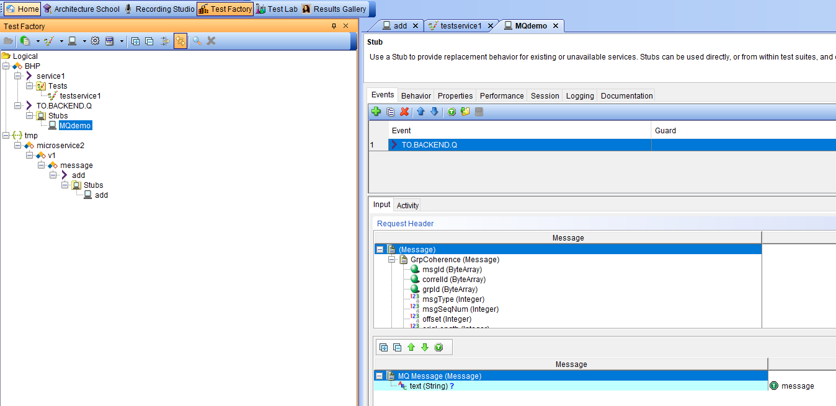

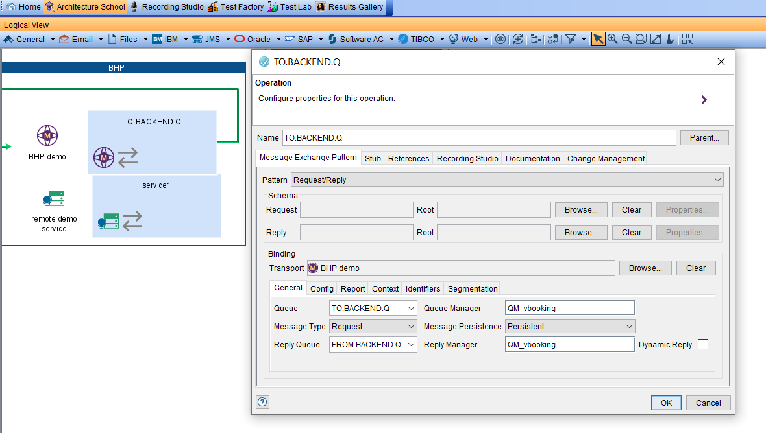

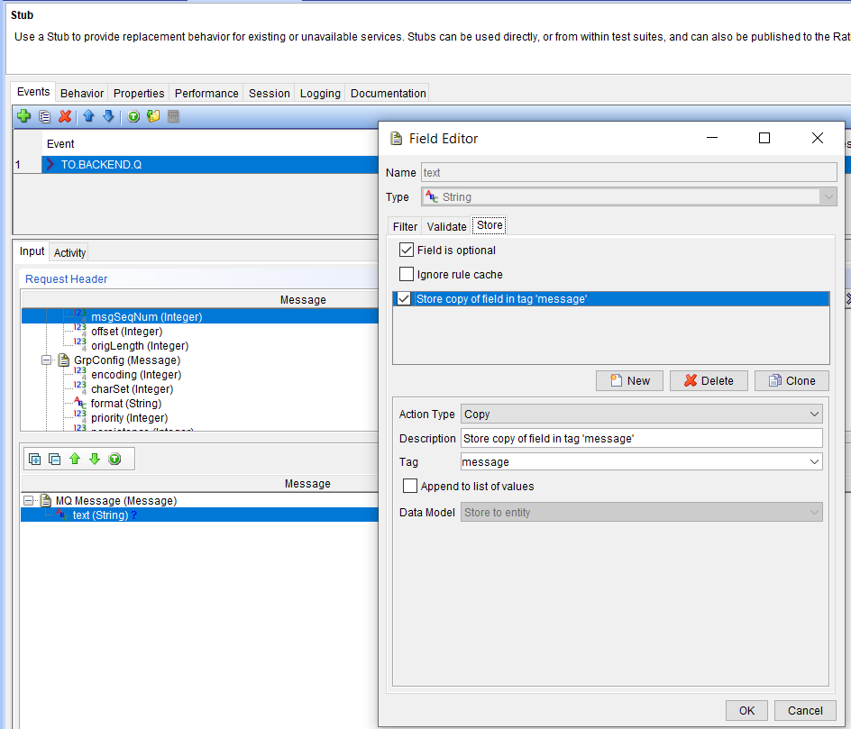

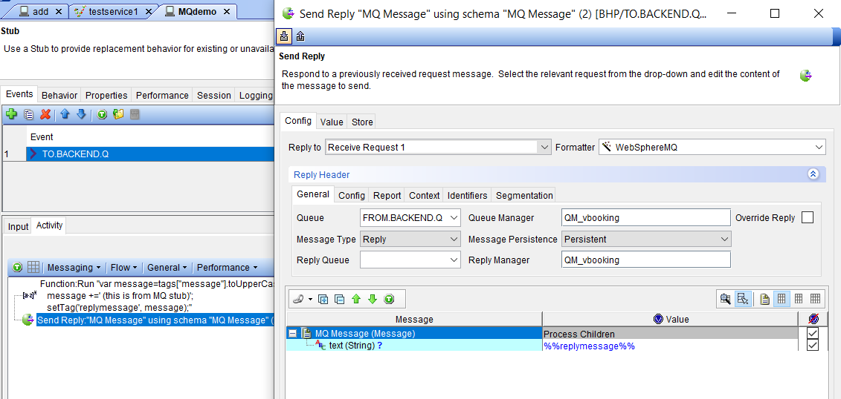

## Configuring MQ

DEFINE CHANNEL(TLSPRQM1.SVRCONN) +

CHLTYPE(CLNTCONN) +

TRPTYPE(TCP) +

CONNAME('ibm-mqadvanced-server-tls-build-da-build-project.apps.cloudpak.ocp4.cloudnativekube.com(443)') +

CERTLABL('ibmmqarnold') +

QMNAME('ibmmqadvancedservertlsbuild2q6v7z') +

SSLCIPH(ANY_TLS12) +

REPLACE

RIT needs a Java Key Store (JKS)

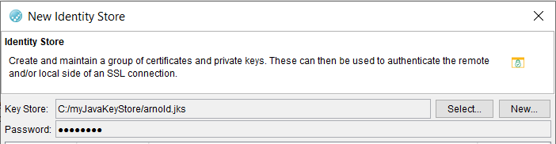

Arnold with password passw0rd

MQ Queue Manager QM_RHOS

ibmmqadvancedservertlsbuild2q6v7z

c:\programdata\ibm\mq\AMQCLCHL.TAB

## Configuring HTTP

## Using RIT to test ACE Micro Service 1 on RHOS

## Running ACE Micro Service 2 Stub on RIT

## Testing ACE Micro Service 2 Stub on RIT

POST

http://tt-ibm-ace-mqc-soe-ms2-build-da-build-project.apps.cloudpak.ocp4.cloudnativekube.com/microservice2/v1/message

with data

{"Messages":["Hello From Test Client"]}

should return

{"Messages":["Hello From Test Client","Hello From MicroService 2 after change tekton test"]}

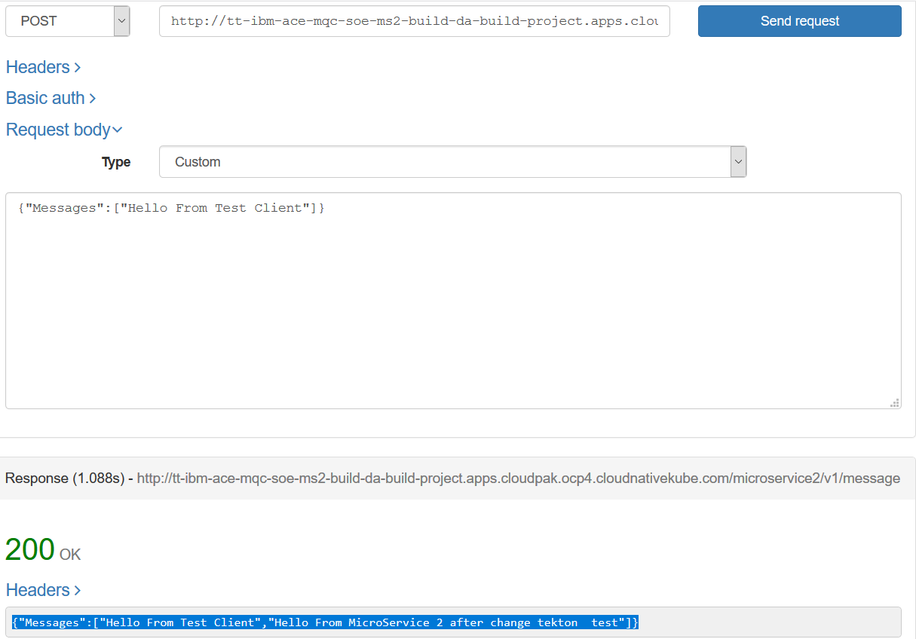

## Secure gateway

### Calling ACE MS2 stub

Client end

You need the IP address that your machine is using at the timel could be wifi adapter, Bluetooth or IBM 9. Address – depends + plus the port. In this example my queue manager is listening on 1515 and my RIT RSVT stub for ACE MS2 is listening on 8080

192…. Is my wifi adapter when at gome.

172 … I my Bluetooth when connected on the phone

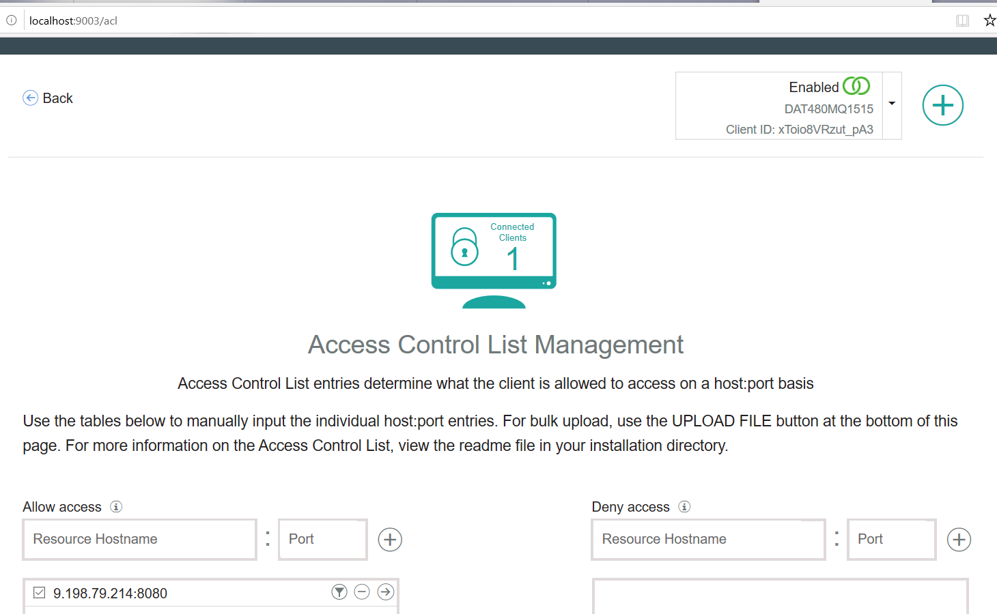

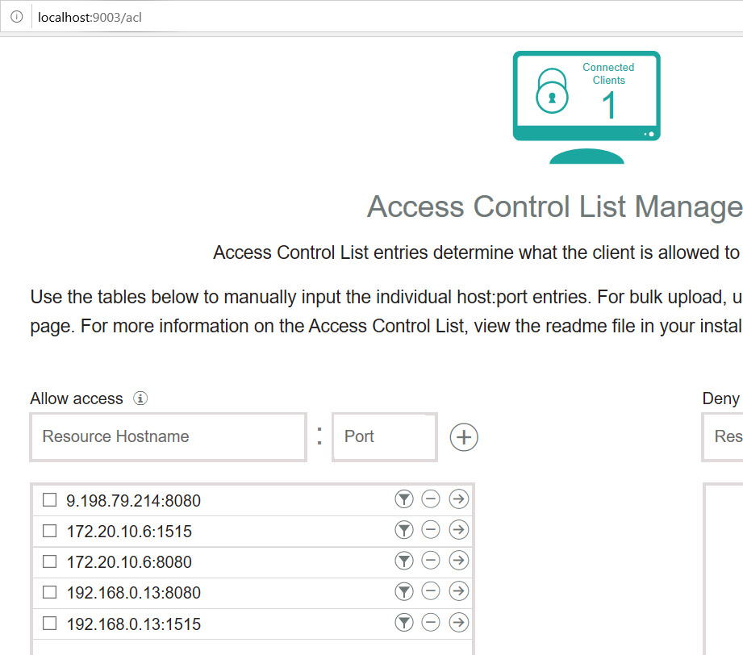

As per the client end you need to toggle the server end between IP/port combinations

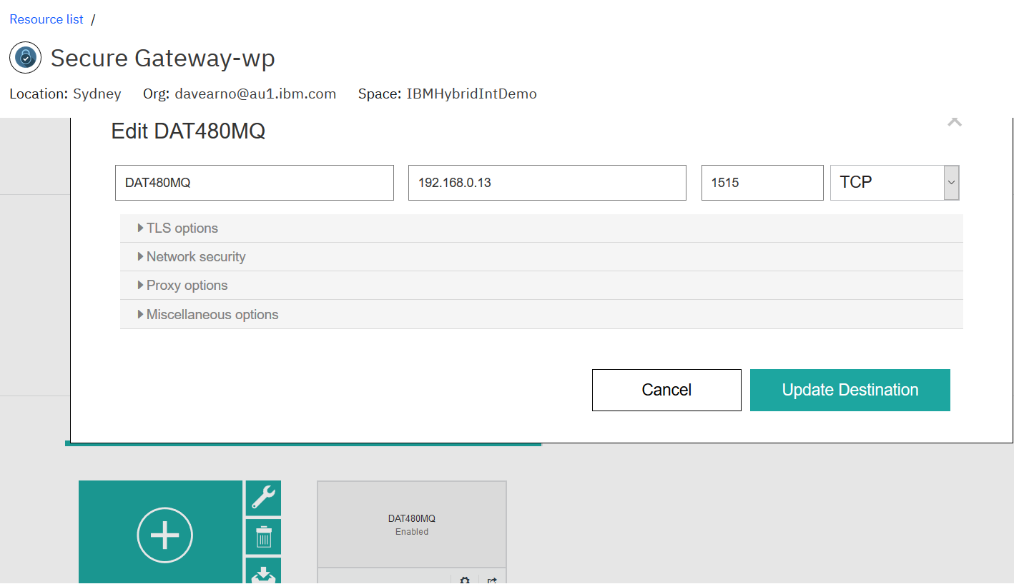

If on windows you will likely need to open the firewall

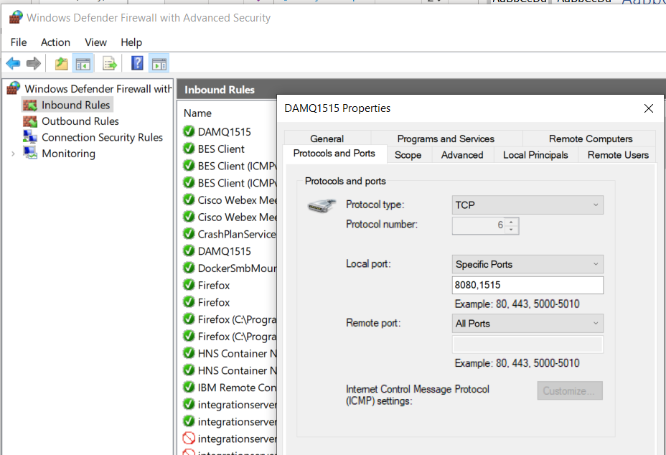

Server End

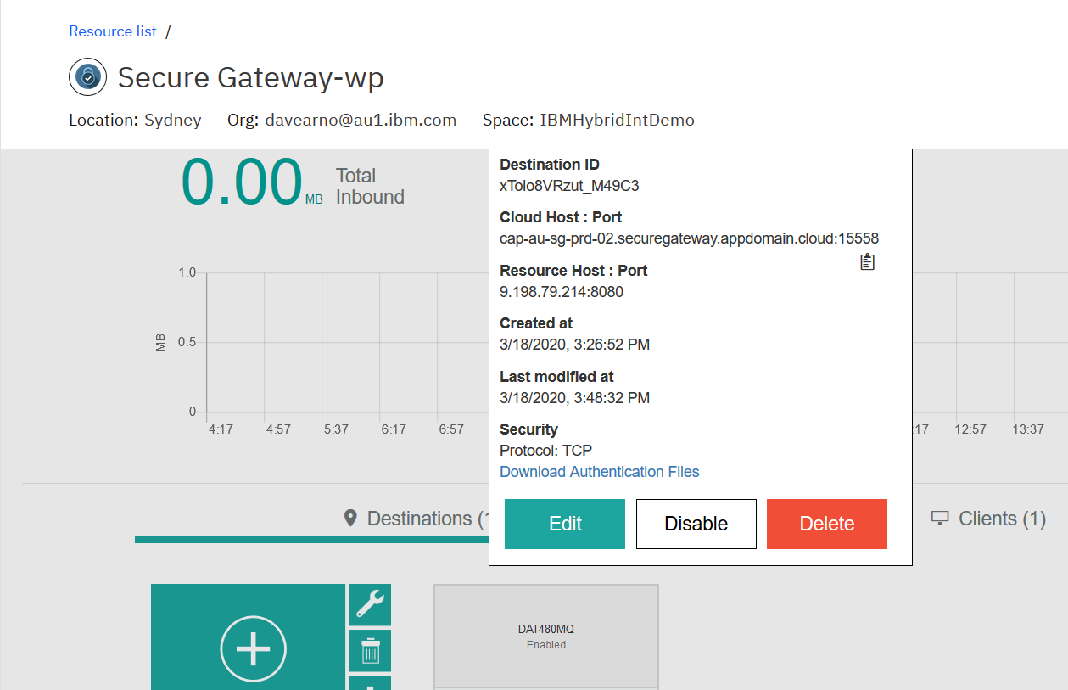

Calling RSVT ACE MS2 stub via public IP

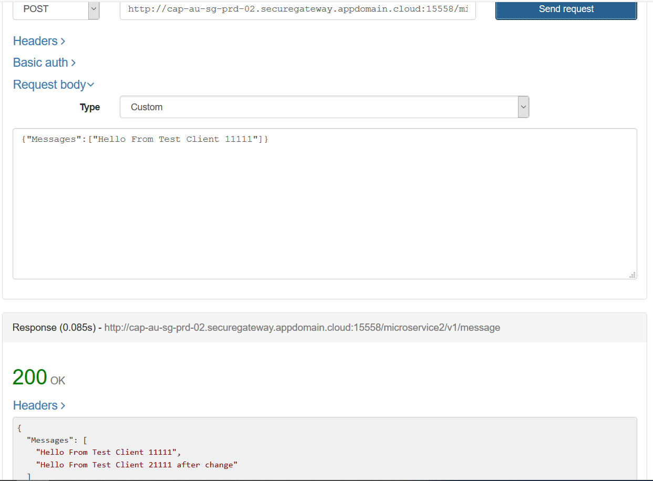

## IBM MQ Queue Manager

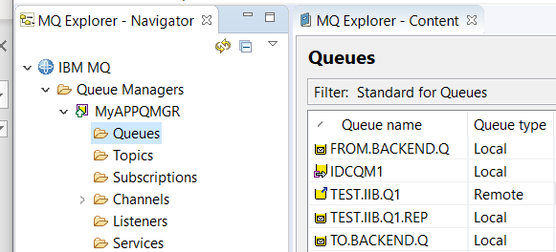

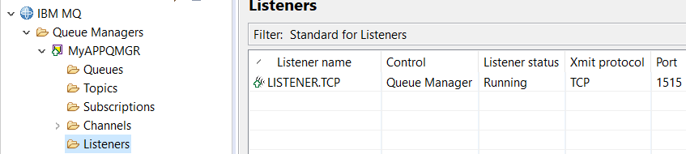

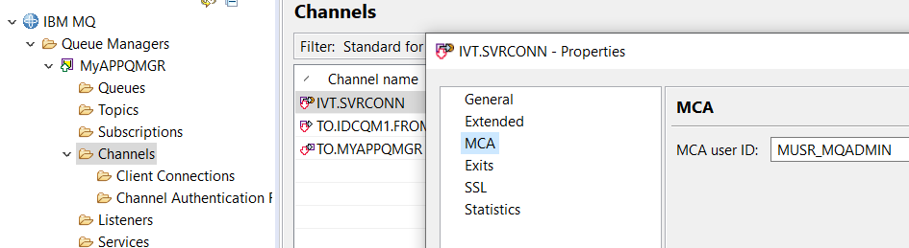

### Channel creation for Linux based queue manager

DEFINE CHANNEL(IVT.SVRCONN) CHLTYPE(SVRCONN) REPLACE

SET CHLAUTH(IVT.SVRCONN) TYPE(BLOCKUSER) USERLIST(nobody)

ALTER AUTHINFO(SYSTEM.DEFAULT.AUTHINFO.IDPWOS) AUTHTYPE(IDPWOS) CHCKCLNT(NONE) ADOPTCTX(YES)

SET CHLAUTH(IVT.SVRCONN) TYPE (ADDRESSMAP) ADDRESS(*) MCAUSER('mqm')

REFRESH SECURITY TYPE(CONNAUTH)

### Channel creation for windows based queue manager

DEFINE CHANNEL(IVT.SVRCONN) CHLTYPE(SVRCONN) REPLACE

SET CHLAUTH(IVT.SVRCONN) TYPE(BLOCKUSER) USERLIST(nobody)

ALTER AUTHINFO(SYSTEM.DEFAULT.AUTHINFO.IDPWOS) AUTHTYPE(IDPWOS) CHCKCLNT(NONE) ADOPTCTX(YES)

SET CHLAUTH(IVT.SVRCONN) TYPE (ADDRESSMAP) ADDRESS(*) MCAUSER('MUSR_MQADMIN')

REFRESH SECURITY TYPE(CONNAUTH)

## IBM Secure Gateway Service – IBM Cloud

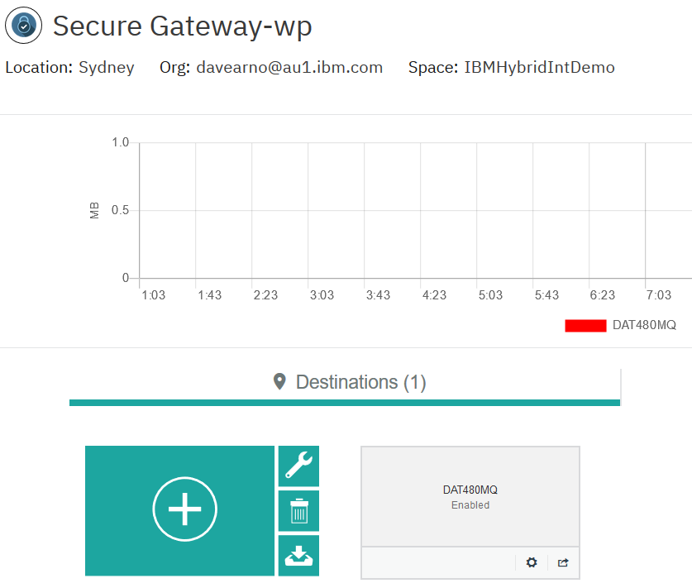

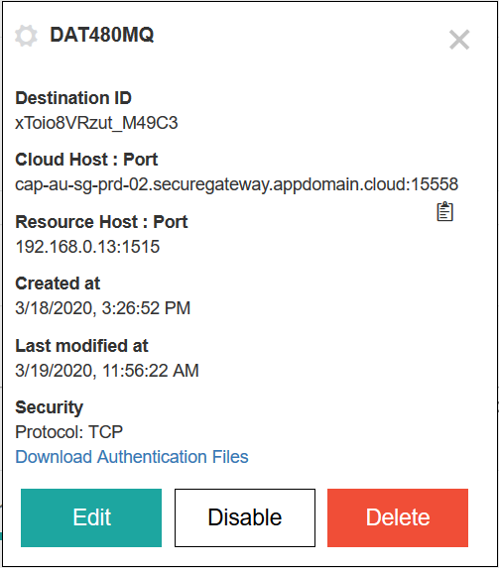

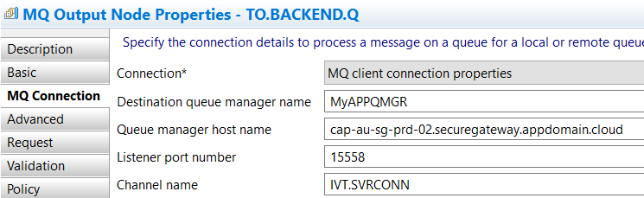

## IBM Secure Gateway Service – Client (Laptop end)

### Windows firewall



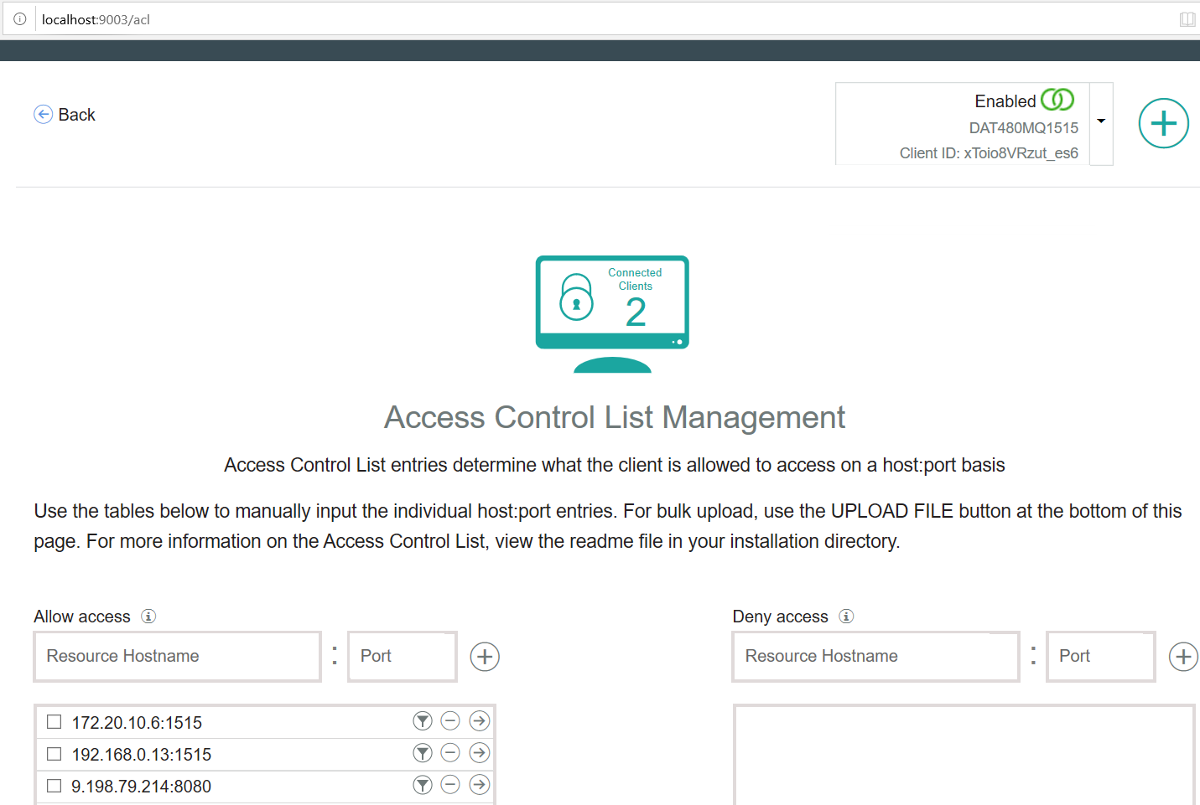

## Testing MQ via IBM Public IP – using RFHUTILC

IVT.SVRCONN/TCP/cap-au-sg-prd-02.securegateway.appdomain.cloud(15558)

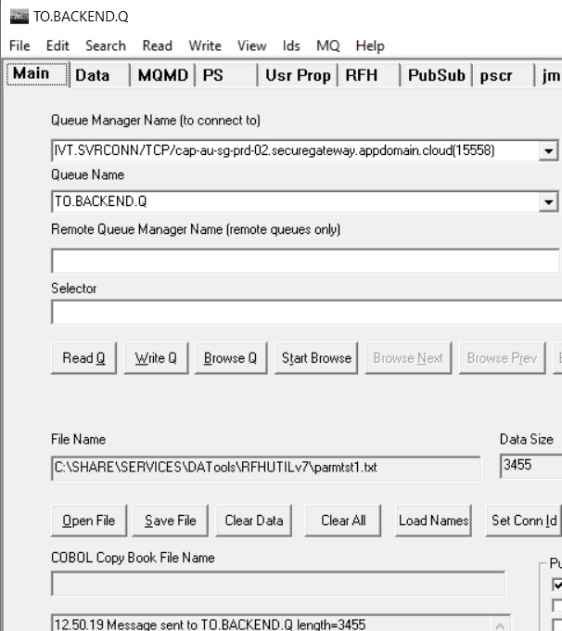

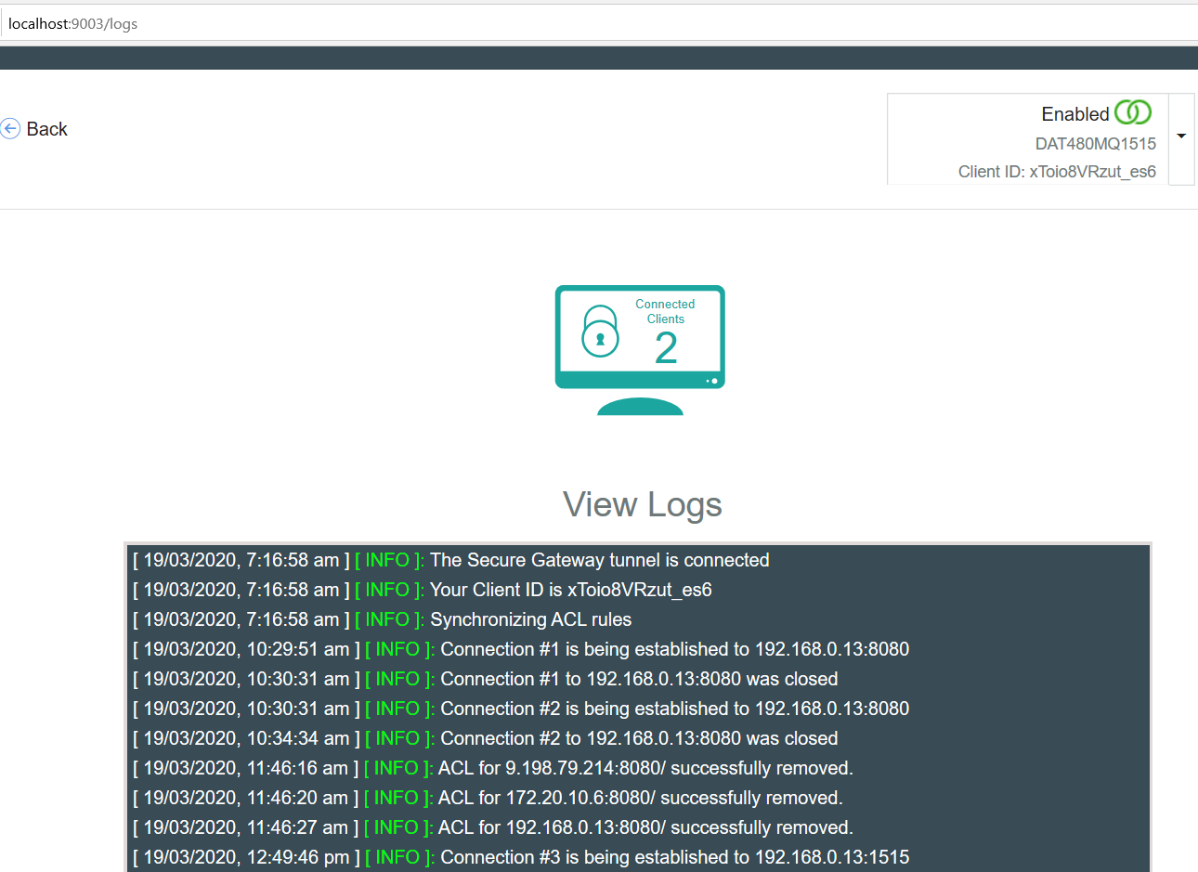

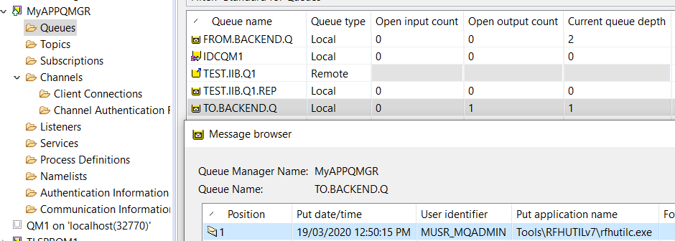

## Testing ACE Microservice 3 to Put to MQ via IBM Public IP

### Route for ACE MS3

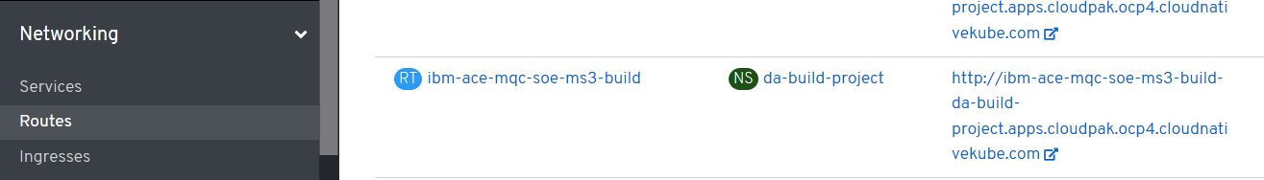

### URL for ACE MS3 service

<http://ibm-ace-mqc-soe-ms3-build-da-build-project.apps.cloudpak.ocp4.cloudnativekube.com/ivtrest/v1/doiIvt>

### Data to test ACE MS3 service

{

"name":"anyname",

"phone":"123545454",

"email": "anyname@host.com"

}

### Test with REST Client

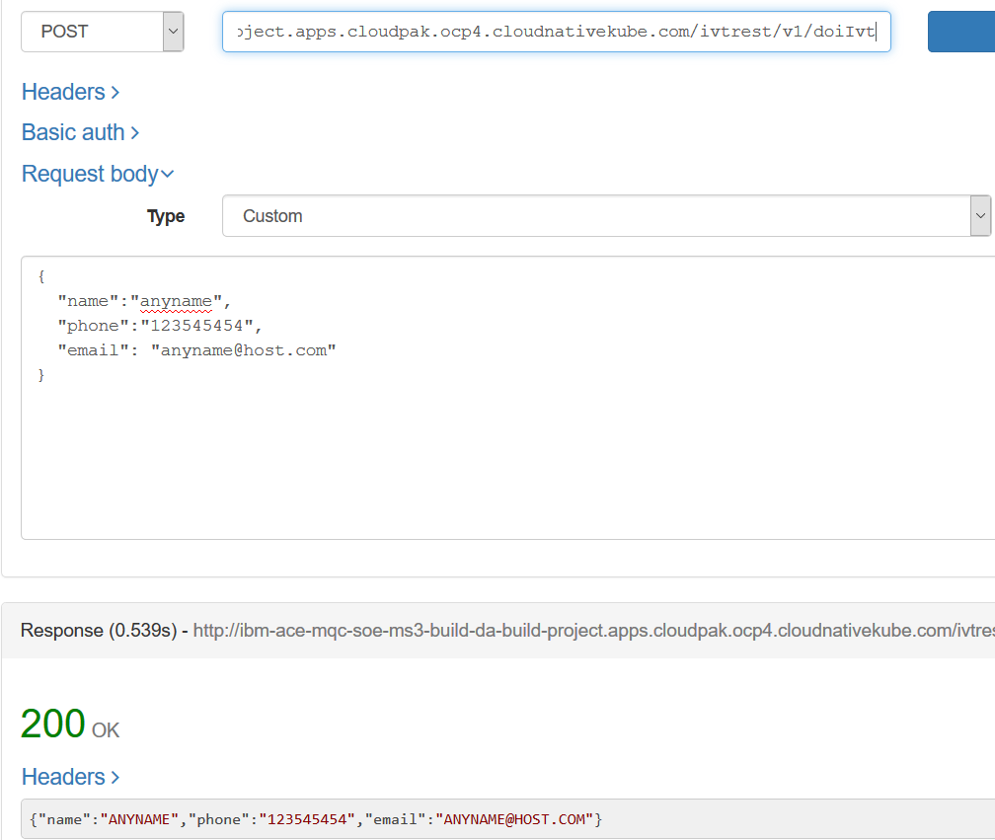

### Test Results

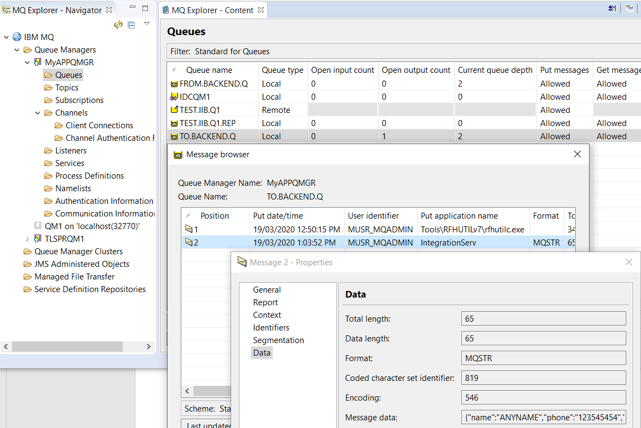

## MQ Stub on RIT

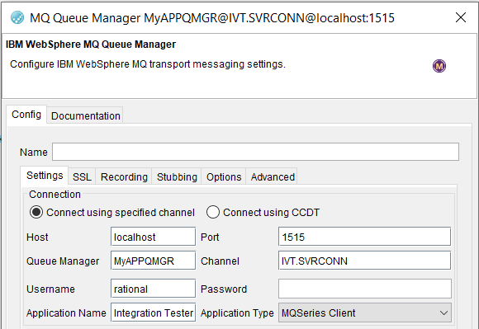

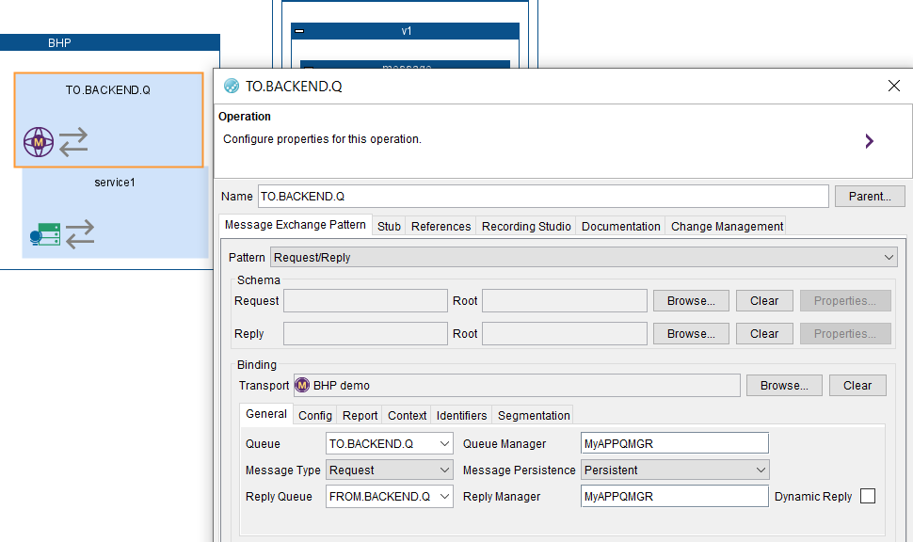

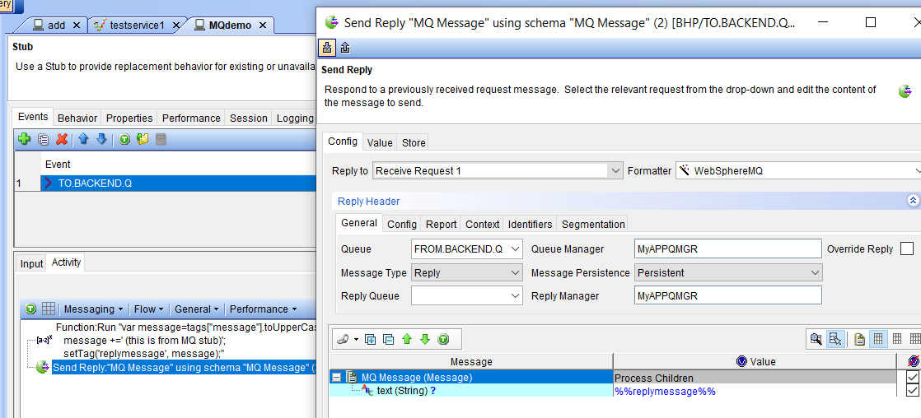

DEFINE CHANNEL(IVT.SVRCONN) CHLTYPE(SVRCONN) REPLACE

SET CHLAUTH(IVT.SVRCONN) TYPE(BLOCKUSER) USERLIST(nobody)

ALTER AUTHINFO(SYSTEM.DEFAULT.AUTHINFO.IDPWOS) AUTHTYPE(IDPWOS) CHCKCLNT(NONE) ADOPTCTX(YES)

SET CHLAUTH(IVT.SVRCONN) TYPE (ADDRESSMAP) ADDRESS(*) MCAUSER('')

REFRESH SECURITY TYPE(CONNAUTH)

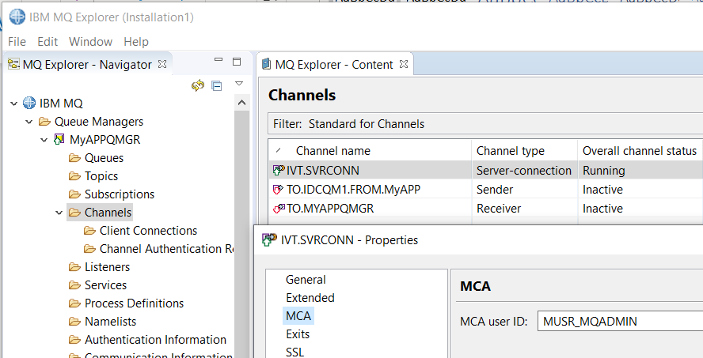

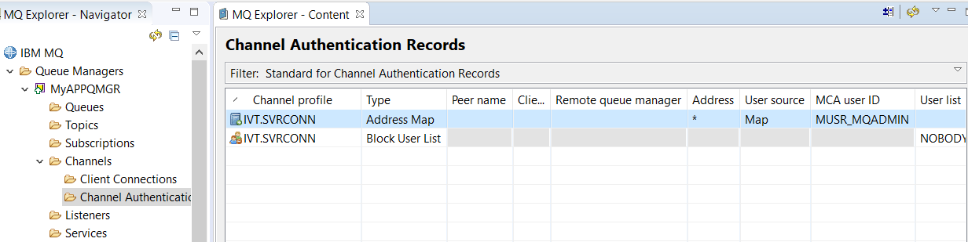

### RIT Test Stub receives message from ACE MS3

